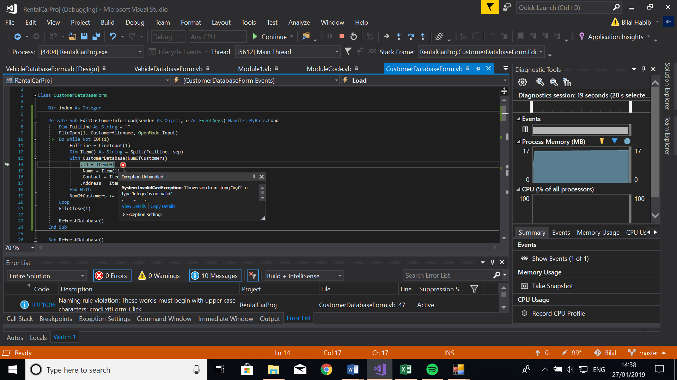

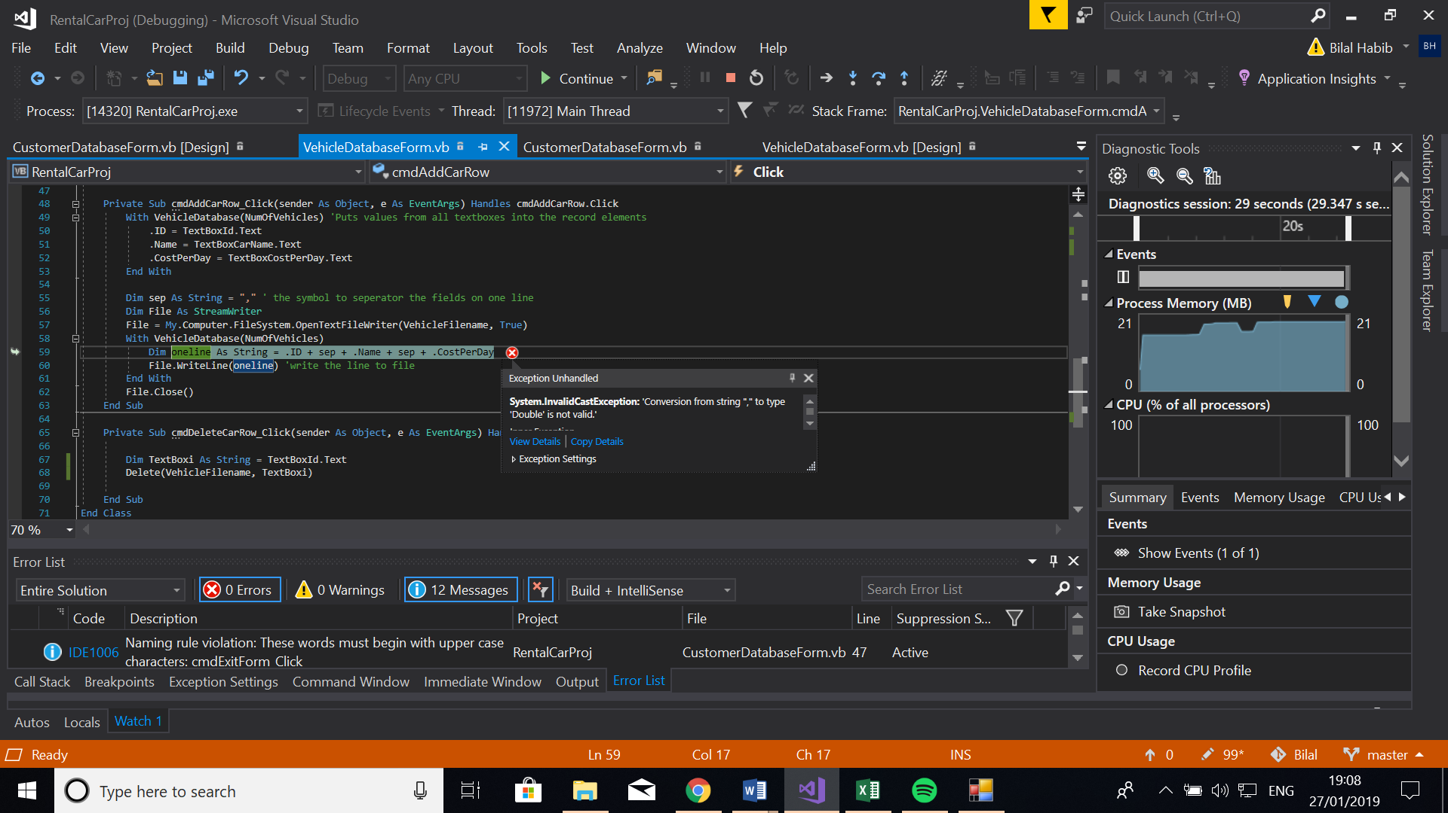

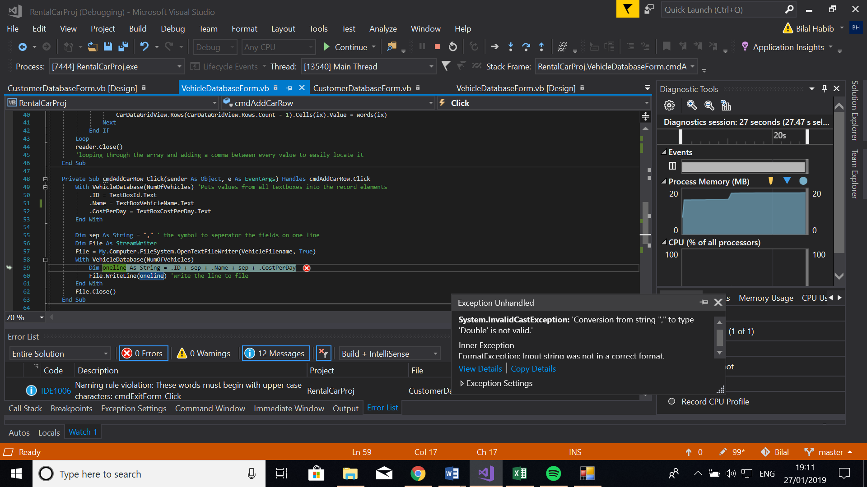

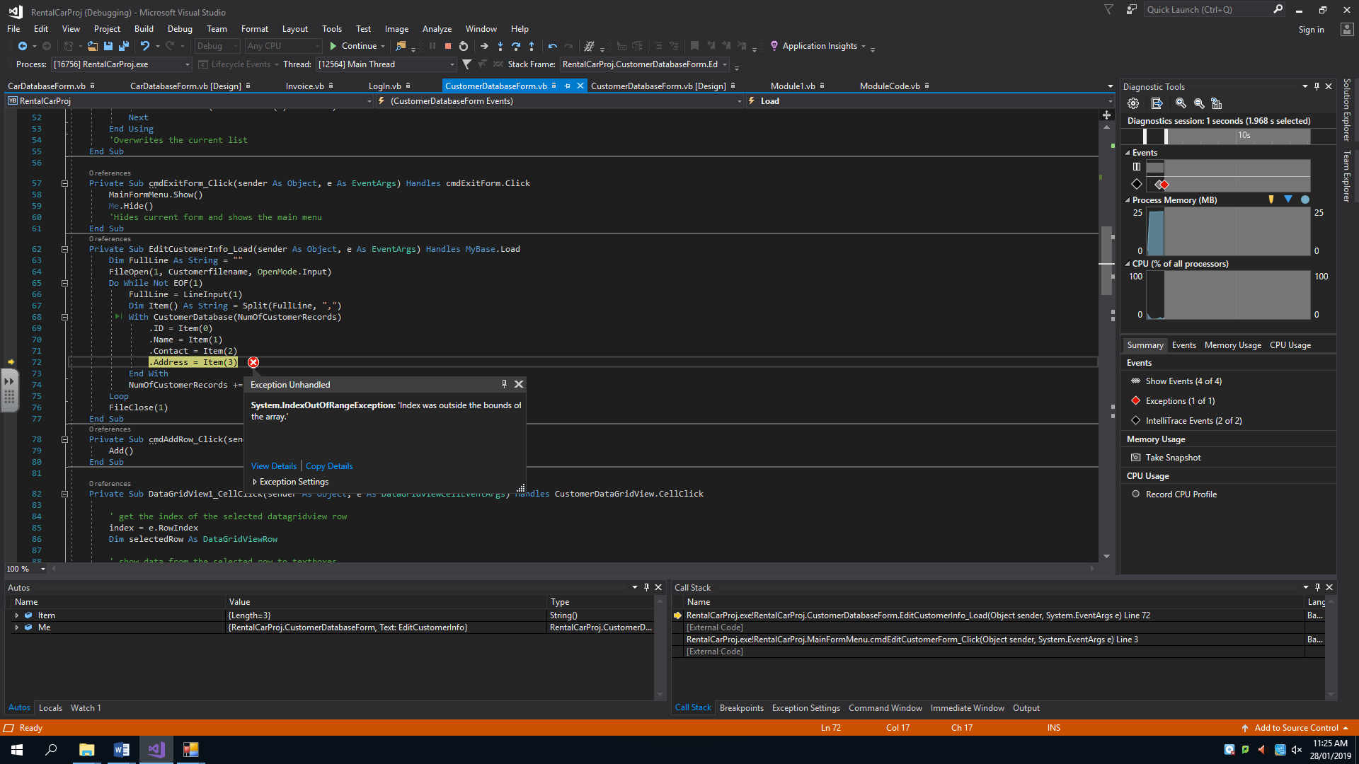

Login Error:

Private Sub cmdLogIn_Click(sender As Object, e As EventArgs) Handles cmdLogIn.Click

For i As Integer = 0 To NumOfStaff - 1

'Loops through every record

If username.Text = StaffDatabase(i).Username And password.Text = StaffDatabase(i).Password Then

'Compares the username and password with the record at index i (every record)

MessageBox.Show("Access Granted")

MainFormMenu.Show()

Me.Hide()

FileClose(1)

Else

MessageBox.Show("Access Denied")

'Displays a message box to tell them if they have succeeded

End If

Next

End Sub

Message box appears too many times, implemented an if statement to avoid this.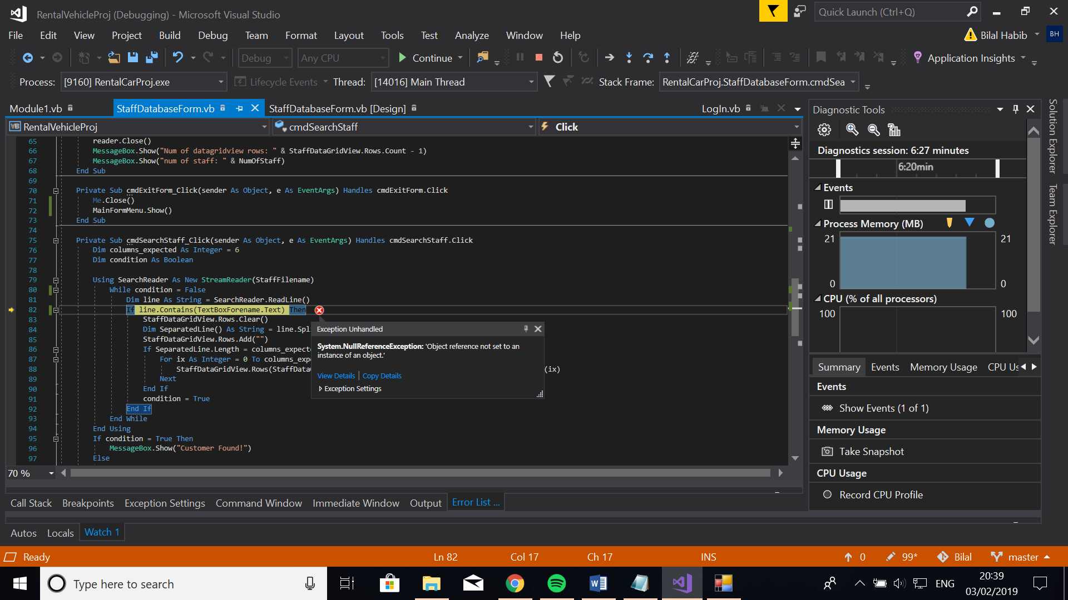

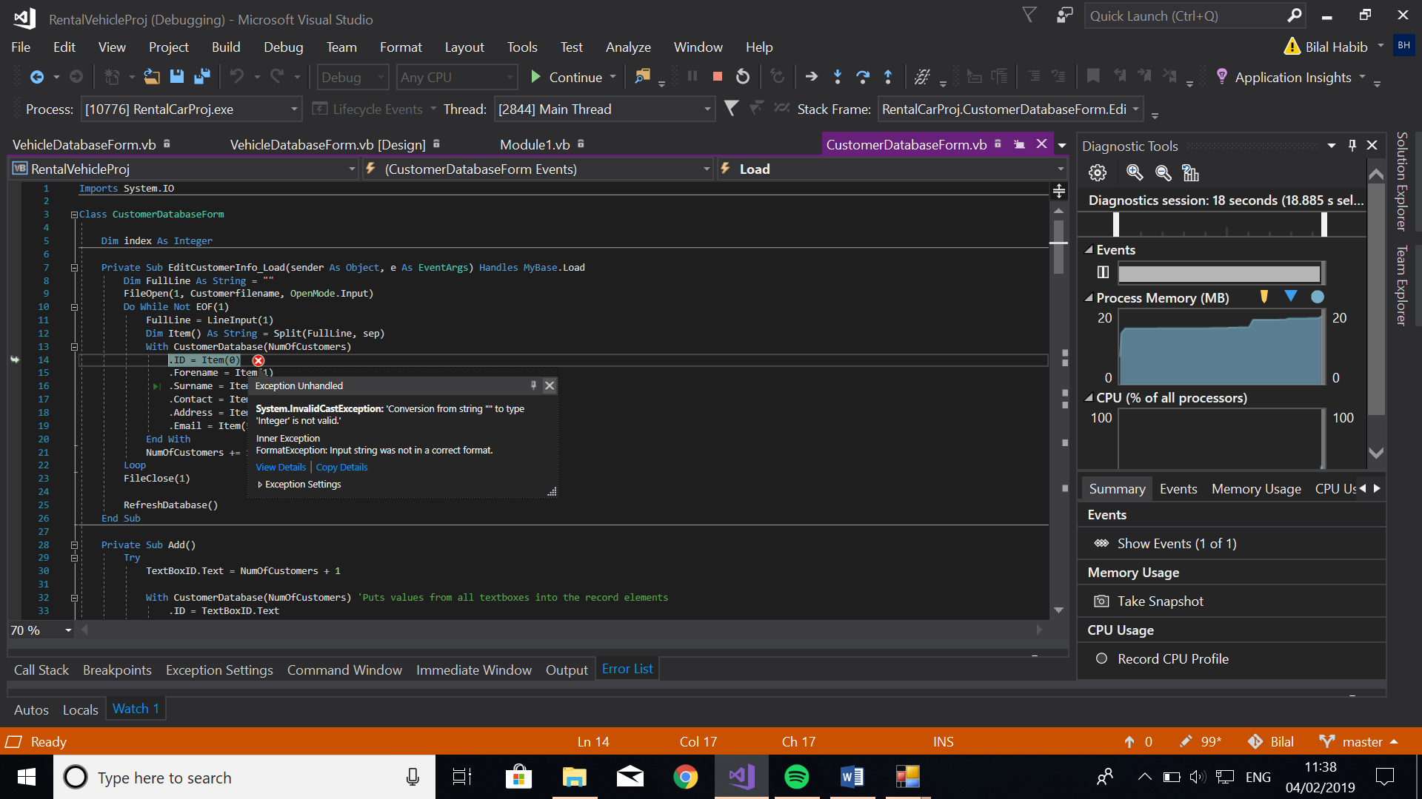

Focus on memory use

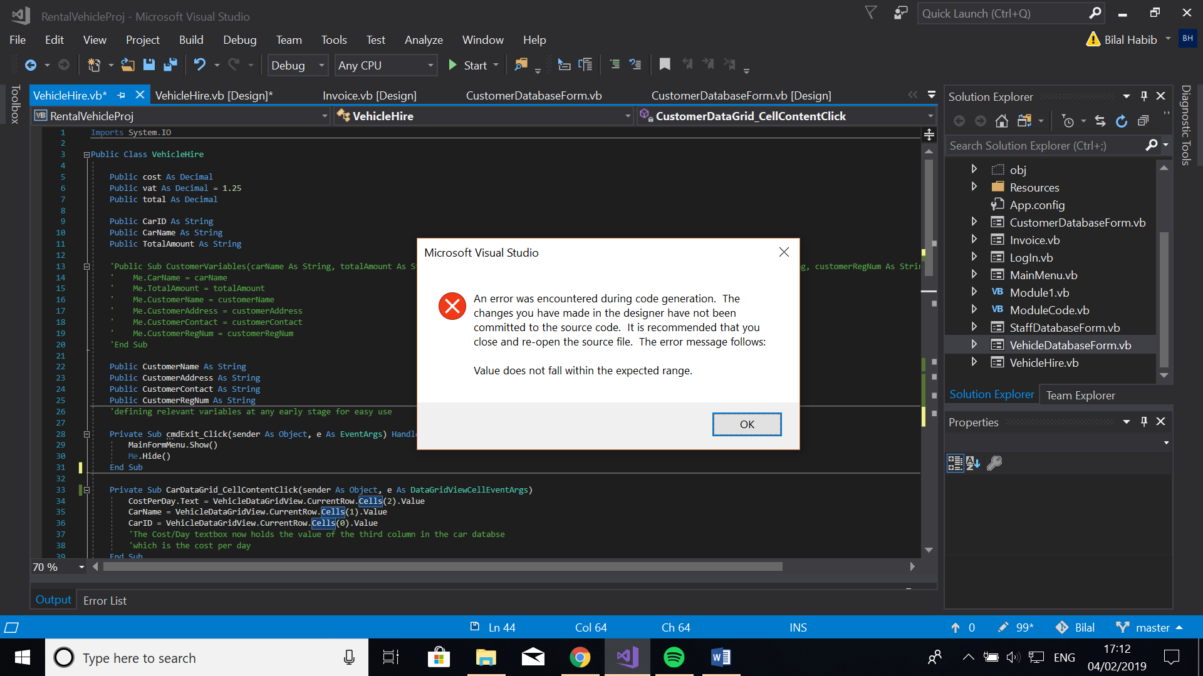

Error with visual studio, out of my control

'Private Sub CarDataGrid_CellContentClick(sender As Object, e As DataGridViewCellEventArgs)

' CostPerDay.Text = VehicleDataGridView.CurrentRow.Cells(2).Value

' CarName = VehicleDataGridView.CurrentRow.Cells(1).Value

' CarID = VehicleDataGridView.CurrentRow.Cells(0).Value

' 'The Cost/Day textbox now holds the value of the third column in the car databse

' 'which is the cost per day

'End Sub This code was the error

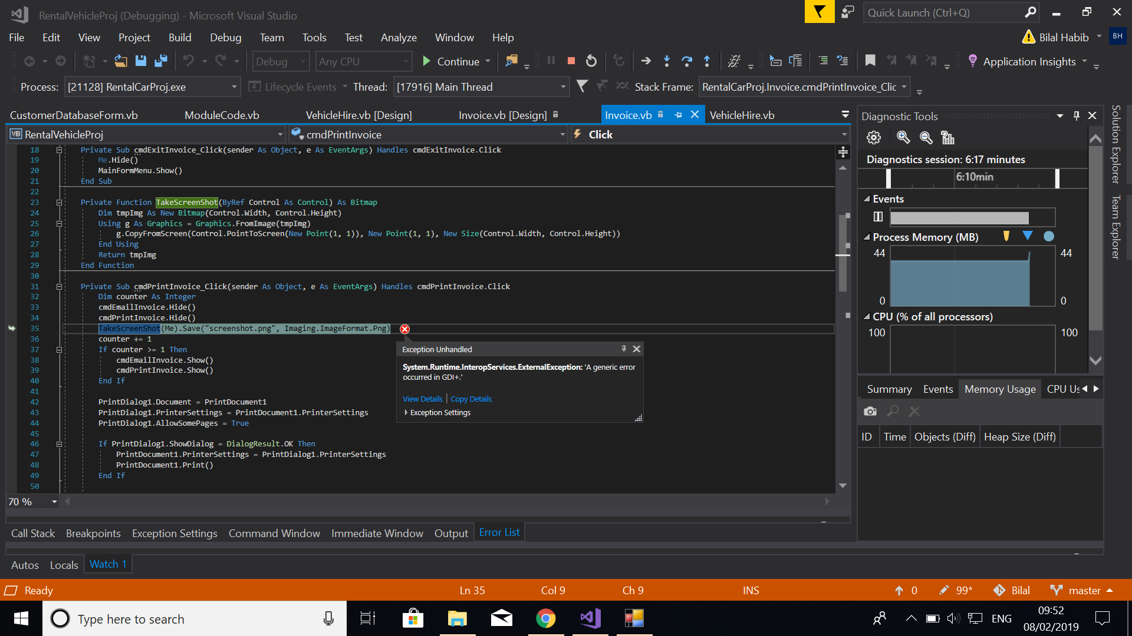

This error occurred when I clicked on the print button, twice.

To fix this save the image to another file when counter > 1

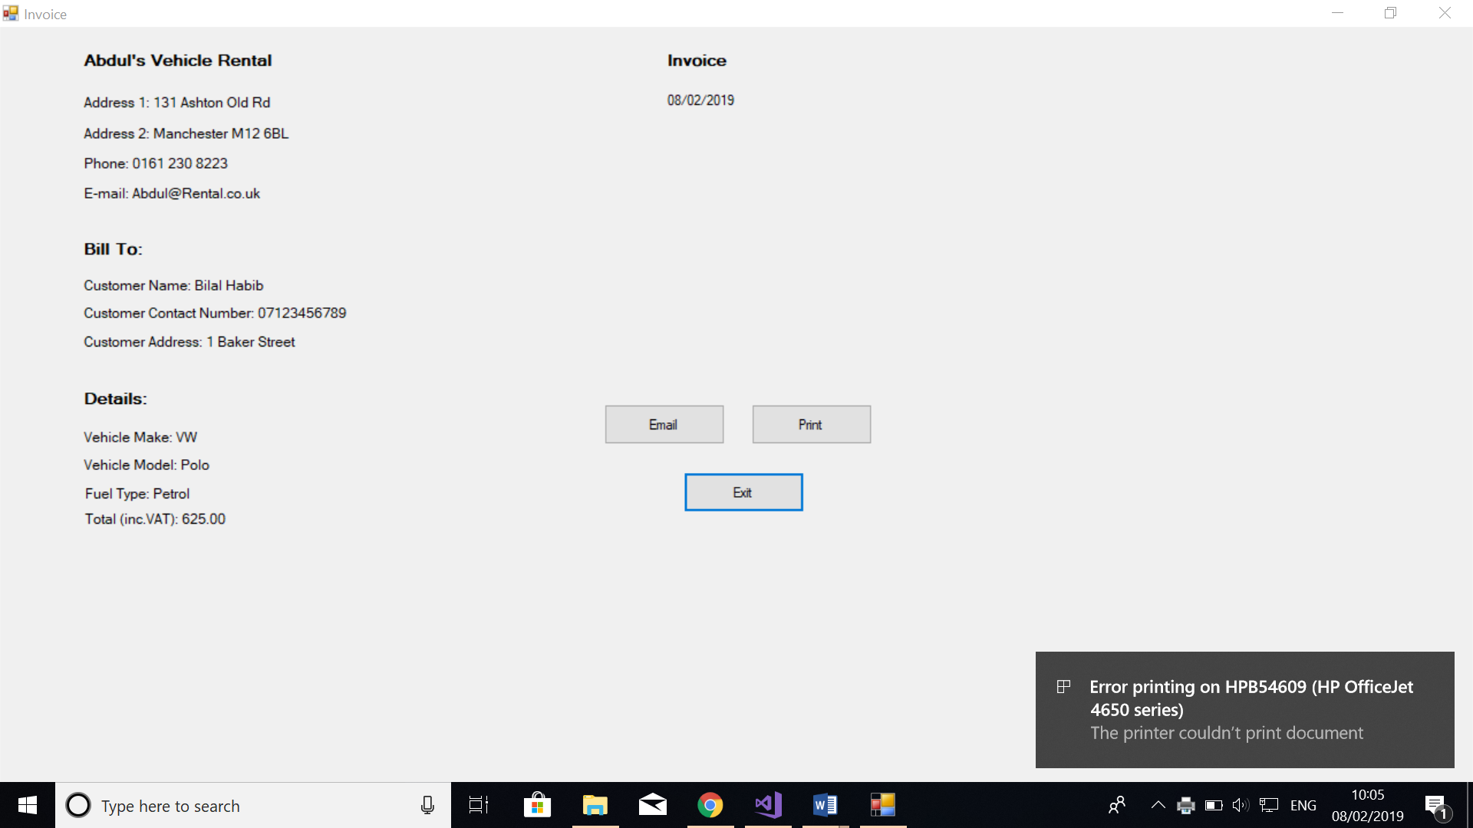

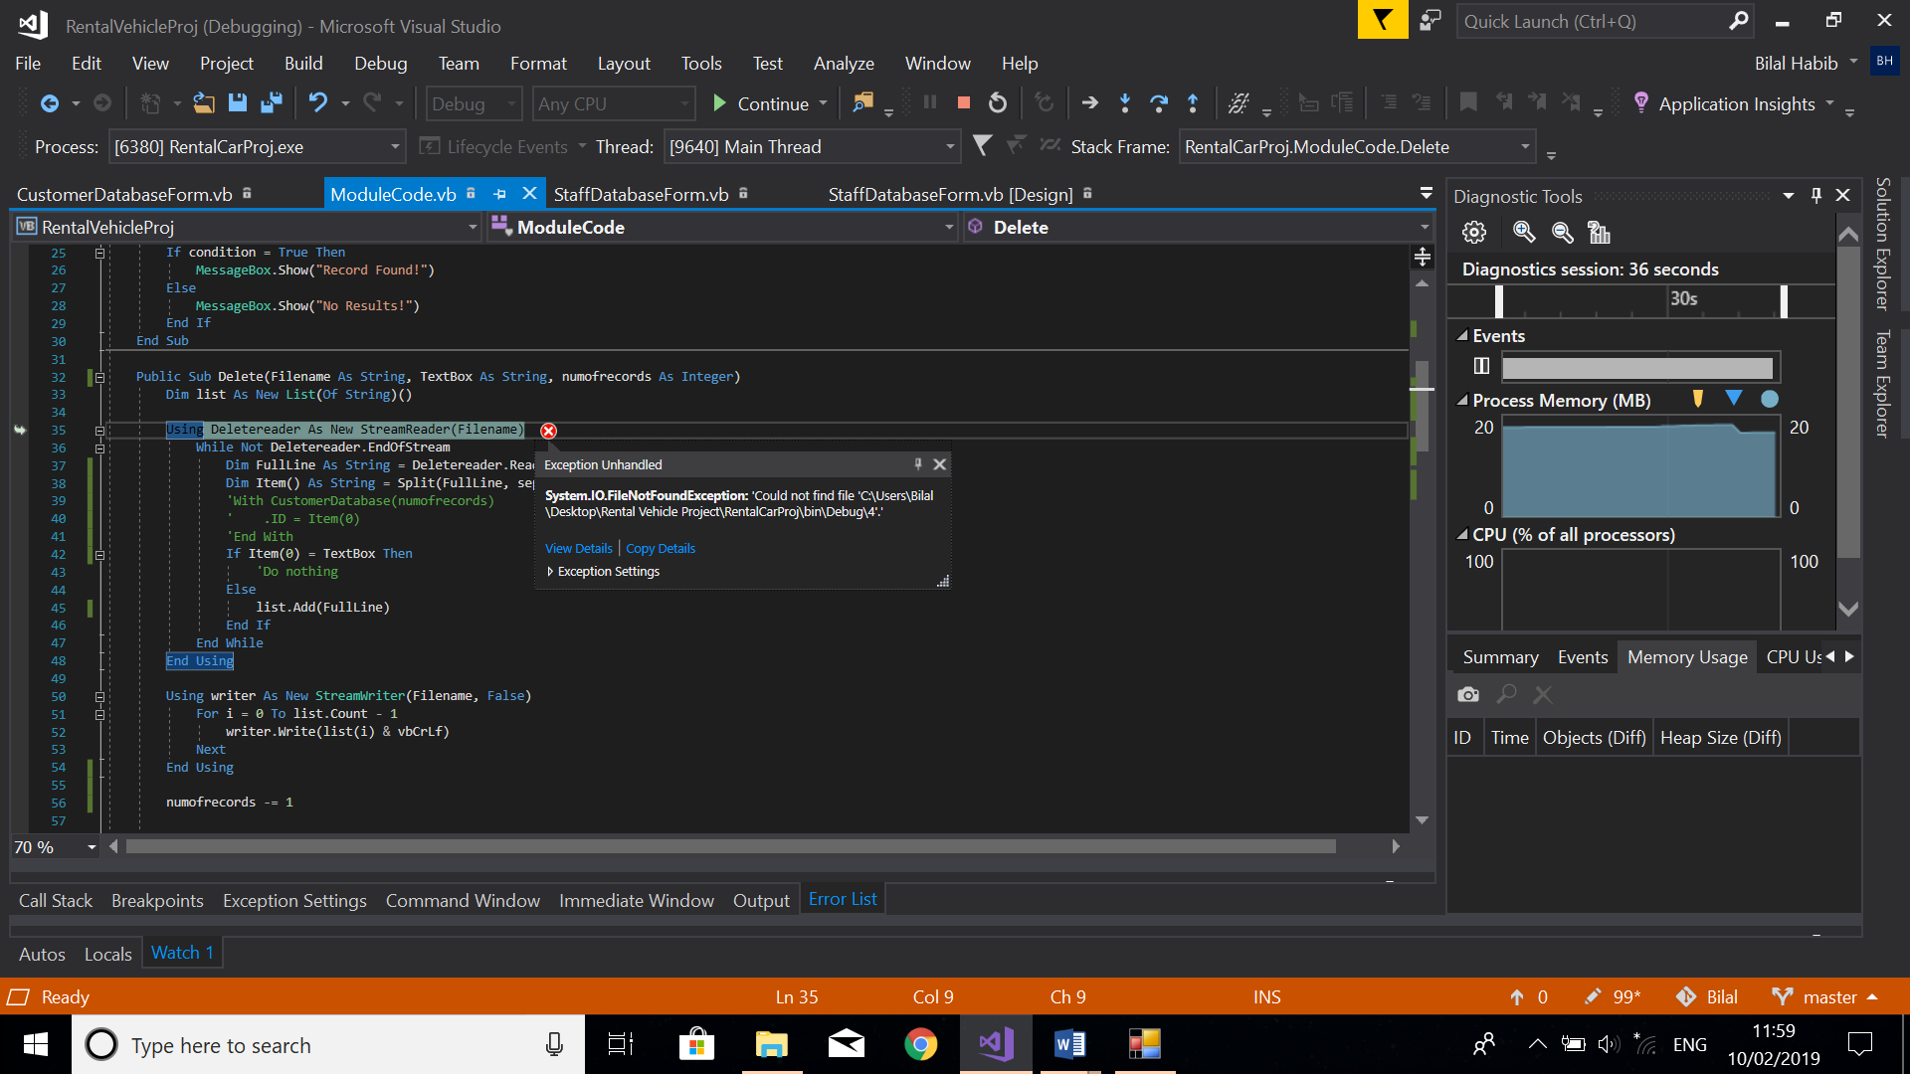

This error occurred when I tried passing in parameters for the staff database delete button. I passed in parameters in the wrong order and therefore the wrong values were passed in.

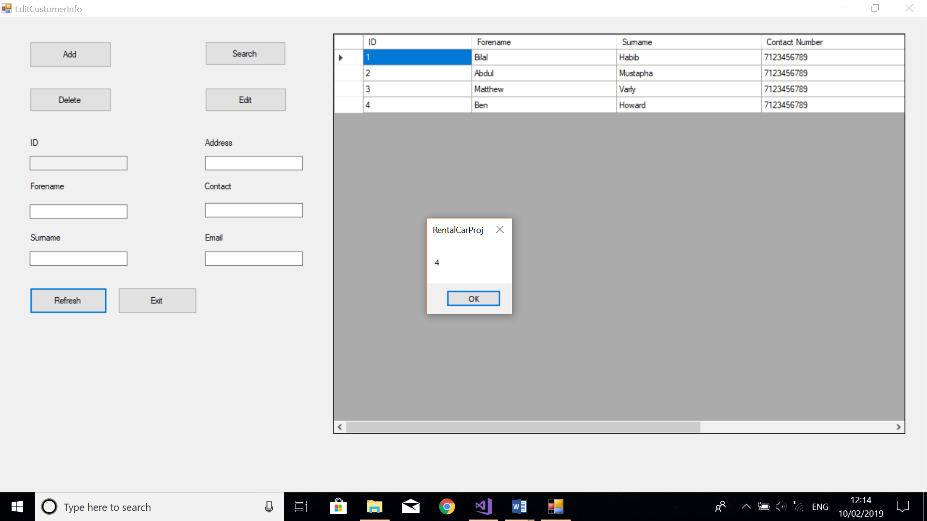

This is proof that the load button works.